


FPT ACADEMY INTERNATIONAL

FPT – APTECH COMPUTER EDUCATION

PIZZA SHOP

Center Name |  | FPT – Aptech – HCM2  Address: 590 Cach Mang Thang Tam, District 3, Ho Chi Minh City
Instructor |  | Ms. Le Mong Thuy
Class |  | T1.2109.M1
Group |  | 6
Group members |  | Name | Student ID
 |  | Nguyễn Minh Vương | Student1339528
 |  | Đồng Thái Tuấn | Student1322489
Duration | Start date | 9th Dec 2021
Duration | End date | 10th Jan 2022

This is to certify that

Mr.:

Nguyễn Minh Vương

Đồng Thái Tuấn

has successfully designed & developed

eProject: Pizza Shop Website

Submitted by:

Nguyễn Minh Vương

Date of issue:
9th Dec 2021

Authorized Signature:


TABLE OF CONTENTS
FPT-APTECH COMPUTER EDUCATION 1
ACKNOWLEGMENT 3
SYNOSIS 3
PROBLEM DEFINITION 3
CUSTOMER’S REQUIREMENTS SPECIFICATION (CRS) 4
Business/project Objective 4
Hardware/software Requirements 5
SCOPE OF THE WORK (IN BRIEF) 6
Architecture and design of the system 7
Diagram of website 8
TASK SHEET REVIEW 1 9
SITE MAP 10
MOCK OF THE WESITE 11
1. Home page 11
2. Menu Shop 12
3. Features 13
4. Gallery 14
5. Logo 15
6. About us 16
7. Contact us 17
TASK SHEET REVIEW 2 19
WEBSITE DISCRIPTION 20
1. Home page 20
2. Shop 21
3. Product categories 21
4. Features 22
5. Gallery 23
6. About us 24
7. Contact us 25
JAVASCRIPT DISCRIPTION 27
1. Product data and javascript 27
2. Filter javascript 30
3. Comparison javascript 31
4. Add to cart javascript 34
5. Contact us javascript 35
TASK SHEET REVIEW 3 36

ACKNOWLEGMENT

On behalf of all the members of group 6, I would like to thank you all for the hard works, supports to make this eProject complete successfully. Especially, Ms. Le Mong Thuy, our teacher, she helped us a lot from the day that we started to study at FPT Aptech. With this eProject, she has guided us with her enthusiasm and rigorous, because of her guiding, we would be able to finish this project. Besides, I want to thank all the team member of group 6, each of the team member has been working continuously in 4 weeks in order to complete this project. The last but not least, we would like to say thank you to our family for always supporting us, creating the best conditions for us to focus on the project, and putting faith in the dreams we pursue.

SYNOSIS
In this mission, our team is tasked with building and developing a website that meets all the needs of customers for Pizza dishes. Our store deals in Pizza, Garlic Breads, drinks, desserts,... and many different items. Our goal is to provide our customers with convenience, comfort and ease of use. Customers can view detailed, specific orders that they want to buy. Besides, the store also has many promotional events displayed on the website for customers to choose from.

PROBLEM DEFINITION

Due to rapid development in internet field, the company decides to launch a website where people will get all the information about the various products available with them easily. You are supposed to create a website for them with the below mentioned requirement specifications.
The website is to be developed for the Windows Platform using HTML5, JavaScript and Geolocation. The site should work well in all leading browsers including Chrome, IE, Firefox etc.

CUSTOMER'S REQUIREMENTS SPECIFICATIONS (CRS)

Client: Pizza Shop

Business/Project Objective:

Due to rapid development in internet field, the company decides to launch a website where people will get all the information about the various products available with them easily. You are supposed to create a website for them with the below mentioned requirement specifications.
The website is to be developed for the Windows Platform using HTML5, JavaScript and Geolocation. The site should work well in all leading browsers including Chrome, IE, Firefox etc.

Input to the system:

- Searching products of pizza shop: pizza, garlic bread, pizza sandwiches, beverages, desserts.

Output from the system:

- A menu that will categorize all the functions of the site.
- Display the list of available pizza category.
- Display the details of item.
- The location of the shop under Contact-Us page.
Progress:
- In the Shop site, users can use filter to sort type of products.

Expected delivery date: 8th-Jan-2022.

List of deliverables:

      - Document Word.
      - Source code.

Hardware/ Software Requirements:

- For developer
Hardware
  - Intel Pentium 4 processor or higher
  - 1 Gigabytes of RAM or higher
Software
  - Windows 7 OS or higher
  - Adobe Dreamweaver
  - Web browsers such as IE, Chrome or Firefox are supporting HTML5, CSS3 and Javascript.

- For web users
Hardware
  - Intel Pentium 4 processor or higher
  - 512 Megabytes of RAM or higher
Software
  - Windows XP OS or higher
  - Web browsers such as IE, Chrome or Firefox are supporting HTML5, CSS3 and Javascript.

SCOPE OF THE WORK (IN BRIEF)

After a long and detailed discussion, our group has decided to create a website contain the following webpages:

- Homepage: We divided the section into 3 parts:
    - Part 1: Display section in carousel/slides: Weekend Special/ Combo offers/ Gallery.
    - Part 2: Display menu best seller items.
    - Part 3: Customer Feedback (display images)

- Menu Shop: display items, sort items by price, favorite,...

- Features: Show downloadable items for details.

- AboutUs: Display store information and customer reviews

- Contact: Display business contacts (address, phone, email, map).

Architecture and design of the system





Webpage request
Requested Page
RENDERING
ENGINE
CSS CODE
HTML CODE
WEB SERVER
WEB BROWSER
CLIENT
SERVER

Diagram of the website

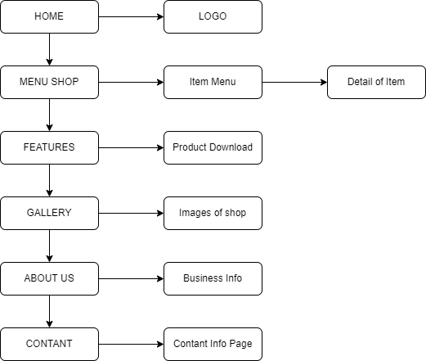






TASK SHEET REVIEW 1

Project Ref. No.:  eP/Advertisement Portal Management  System/01 |  | Project Title: | Activity Plan Prepared By: | Date of Preparation of Activity Plan:
Sr.  No. | Task | Project Title: | Activity Plan Prepared By: | Actual  Start Date | Actual Days | Team Mate Names | Status
1 | Problem Statement | GIFTS SHOP | Nguyễn Minh Vương | 9-Dec-21 | 1 | N.M.Vương | Completed
2 | Analysis of Gifts Shop requirements about the website | GIFTS SHOP | Nguyễn Minh Vương | 9-Dec-21 | 1 | Đ.T.Tuấn | Completed
3 | The scope of the work (in brief) | GIFTS SHOP | Nguyễn Minh Vương | 9-Dec-21 | 1 | N.M.Vương | Completed
4 | Architecture and design of the system | GIFTS SHOP | Nguyễn Minh Vương | 9-Dec-21 | 1 | Đ.T.Tuấn | Completed
5 | Diagram of the website | GIFTS SHOP | Nguyễn Minh Vương | 9-Dec-21 | 1 | Đ.T.Tuấn | Completed
6 | Task Sheet | GIFTS SHOP | Nguyễn Minh Vương | 9-Dec-21 | 1 | N.M.Vương | Completed

Date: 15th July 2021
Signature of Instructor:  Ms. Le Mong Thuy | Signature of Team Leader:  Nguyen Minh Vuong

SITE MAP

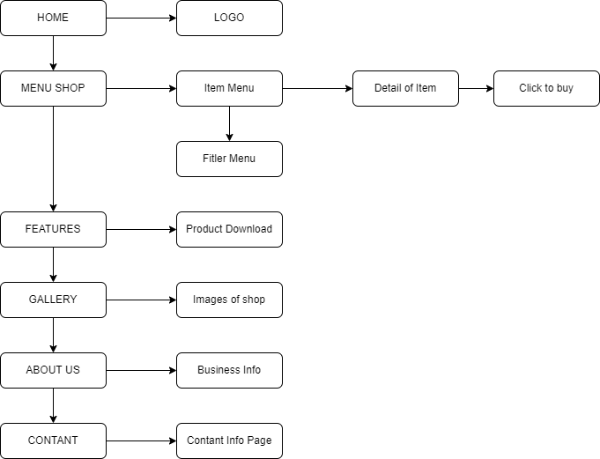

MOCK OF THE WEBSITE

- Homepage

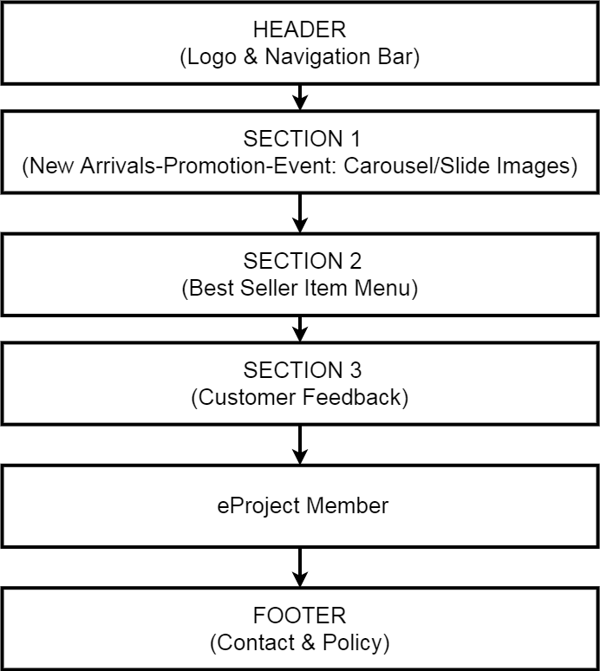

- Shop

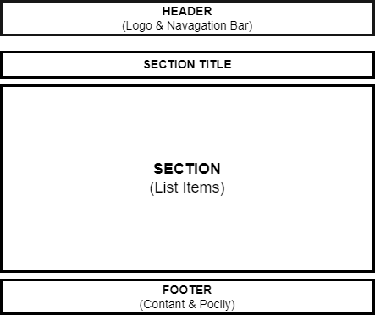

- Features

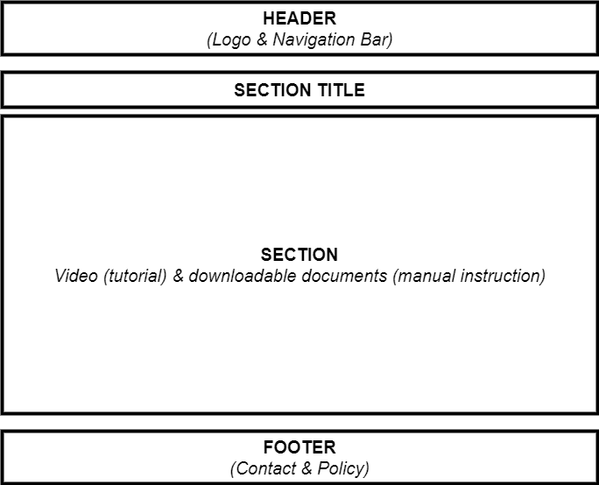

- Gallery

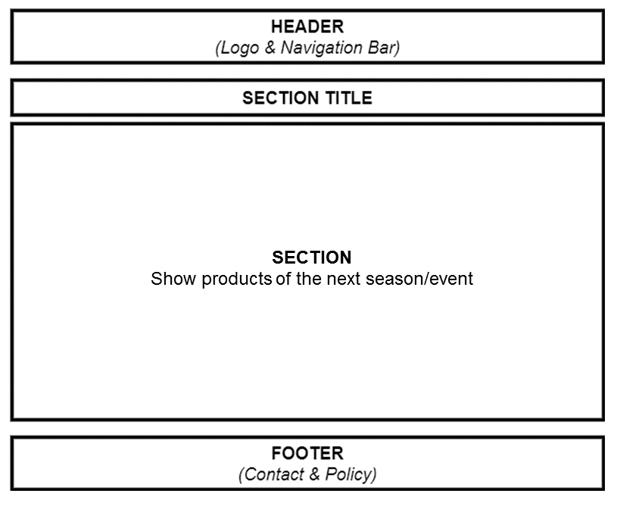

- Logo

This logos designed by Đồng Thái Tuấn-Student1322489


- About us

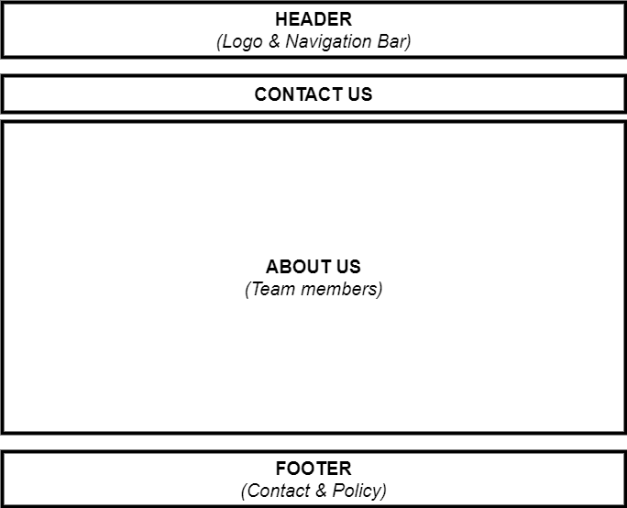

- Contact us

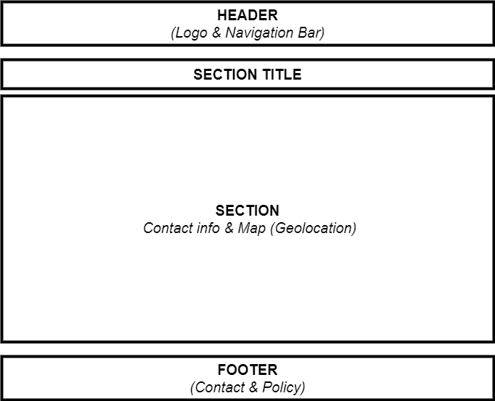

TASK SHEET REVIEW 2

Project Ref. No.:  eP/Advertisement  Portal Management System/01 |  | Project Title: | Activity Plan Prepared By: | Date of Preparation of Activity Plan:
Sr.  No. | Task | Project Title: | Activity Plan Prepared By: | Actual Start Date | Actual Days | Team Mate Names | Status
1 | Site map | PIZZA  SHOP | Nguyễn Minh Vương | 18th-Dec-2021 | 1 | Đ.T.Tuấn | Completed
2 | Mock of the website | PIZZA  SHOP | Nguyễn Minh Vương | 18th-Dec-2021 | 2 | Đ.T.Tuấn | Completed
3 | Task sheet | PIZZA  SHOP | Nguyễn Minh Vương | 18th-Dec-2021 | 2 | N.M.Vương | Completed

Date: 18th Dec 2021
Signature of Instructor:  Ms. Le Mong Thuy | Signature of Team Leader:  Nguyen Minh Vuong

WEBSITE DESCRIPTION

- Home page
- Description
Home page displays following infomation
    - Events
    - Best Seller
    - Feedbacks
  - Screenshot

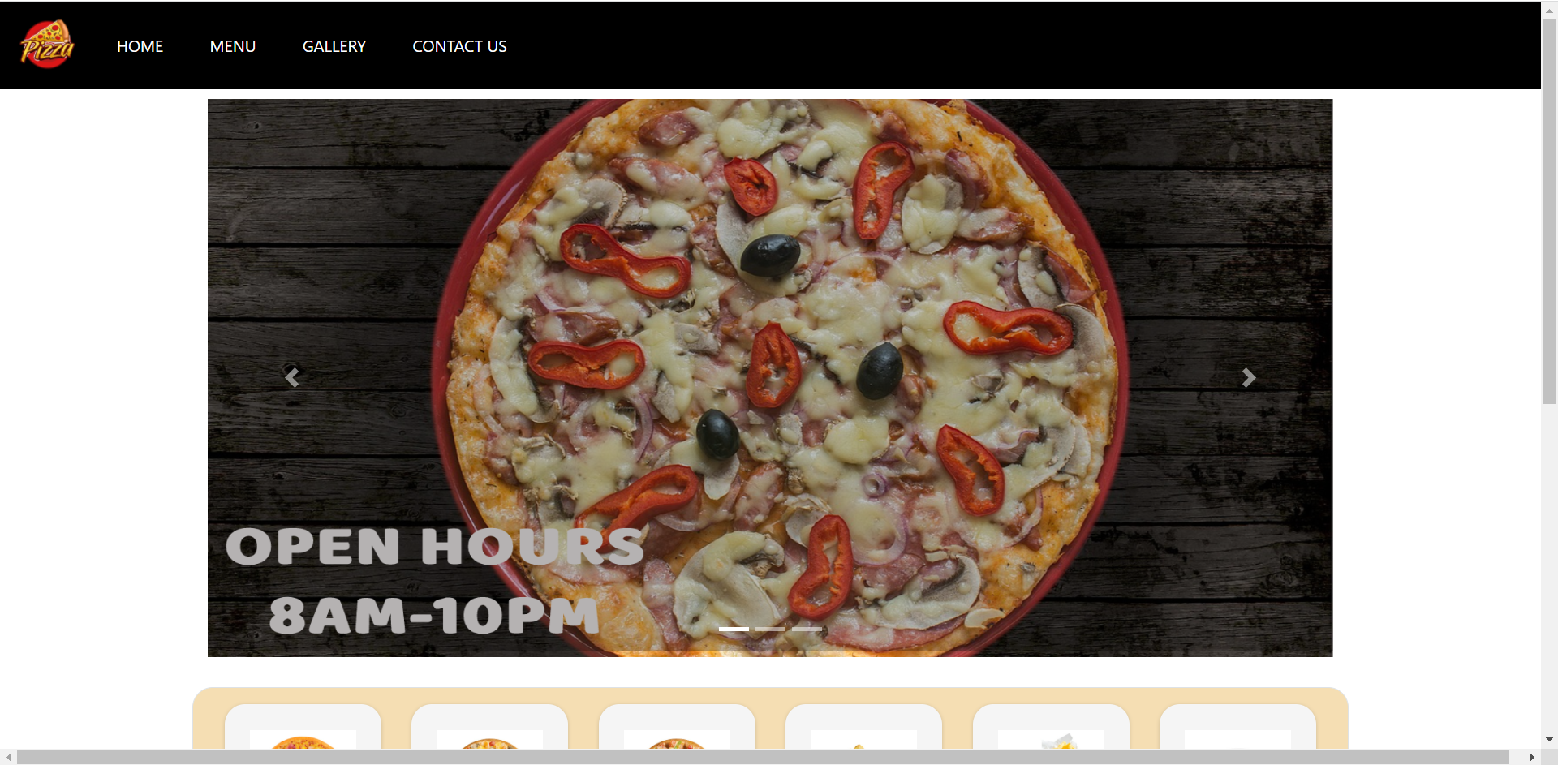

- 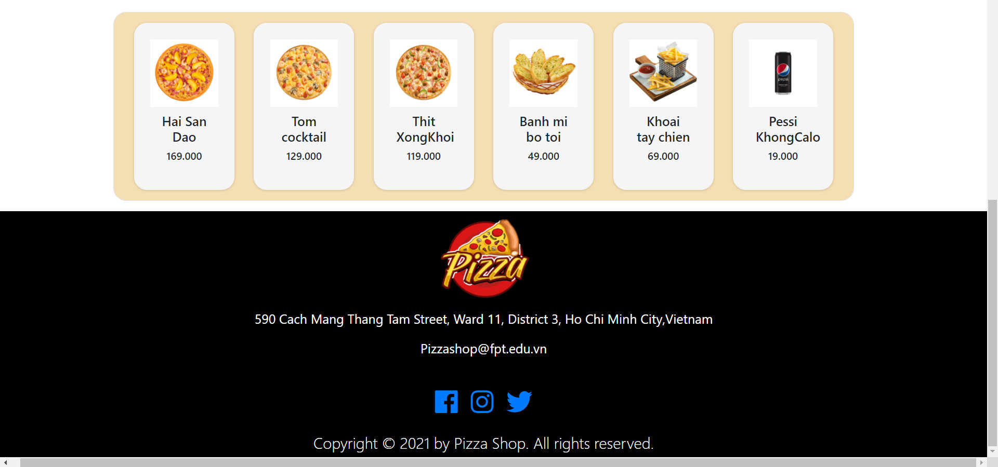
Shop
  - Description
Shop page displays following infomation
    - Show all products at Shop page.
    - Show all product categories:
+ Pizza
+ Galic bread
+ Pizza sandwich
+ Desert
+ Beverager
  - Screenshot

- Product categories
  - Description
Product category pages displays following infomation
    - Show all products of category.
    - Filter by brands and categories.
  - Screenshot

- Featuers
  - Description
This page displays a brief summary of features of individual products.
  - Screenshot

- Gallery
  - Description
This page will displays information about new products of the next season/event.
  - Screenshot

- About us
  - Description
This page will displays information about the history of Gift shop, our service that we provide and our team member.
  - Screenshot

- Contact us
  - Description
This page displays contact information: location, telephone number, email and a quick contact form for customer.
  - Screenshot

- Member
  - Description
This modal displays 2 types of login:
- Login with account which registed directly at local shop.
- Login with social network account.
  - Screenshot

JAVASCRIPT DESCRIPTION
- Product data json and javascript.
  - Description
This script used for adding product detail.
  - Screenshot

b-2 Javascript

b-3 Modal show item’s detail

- Filter javascript
  - Description

This script used for filtering items in the shop page based on categories and brands
  - Screenshot

- Comparison javascript
  - Description

This script used for comparing items in the shop page based on categories and brands
  - Screenshot

- Add to Cart javascript
  - Description

This script used for adding items to cart and show how many item added.
  - Screenshot

- Contact us javascript
  - Description

This script used for contacting to our customer service.
  - Screenshot

TASK SHEET REVIEW 3

Project Ref. No.:  eP/Advertisement  Portal Management System/01 |  | Project Title: | Activity Plan Prepared By: | Date of Preparation of Activity Plan:
Sr.  No. | Task | Project Title: | Activity Plan Prepared By: | Actual Start Date | Actual Days | Team Mate Names | Status
1 | Website layout | Pizza  SHOP
2 | Edit CSS | Pizza  SHOP
3 | Modal javascript | Pizza  SHOP
4 | Filter javascript | Pizza  SHOP
5 | Product detail and data json | Pizza  SHOP
6 | Task sheet review | Pizza  SHOP

Date: 06th August 2021
Signature of Instructor:  Ms. Le Mong Thuy | Signature of Team Leader:

